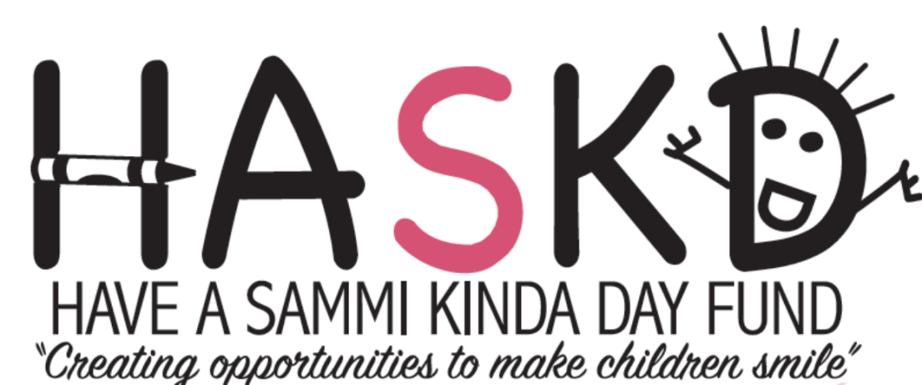

SPONSORSHIP OPPORTUNITIES

The Have A Sammi Kinda Day Fund is pleased to invite you as an individual or your business to participate in our 2nd Annual Golf Tournament by taking advantage of one of the following sponsorship opportunities.
HASKD is a 501c3 approved Non-Profit Organization. The Golf Tournament will be held on Saturday August 24, 2019 at the River Bend Country Club located in west Bridgewater, Massachusetts. The event will host 144 golfers. The HASKD Fund will use the proceeds to support our mission of “Creating opportunities to make children smile”.

DINNER SPONSOR – $500
Company or Individual name displayed at dinner on all tables

HOLE SPONSOR – $100
Company or individual name displayed on sign at Tee Box

Sponsorships can be made by mailing a check payable to HASKD with the completed Sponsorship Form to:

HASKD
P O Box 3514
Plymouth, MA 02361

For more information about our event please contact us via:
email at haveasammikindaday@gmail.com
phone at 508-759-7382

To learn more about our Organization please visit our website at www.haveasammikindaday.com

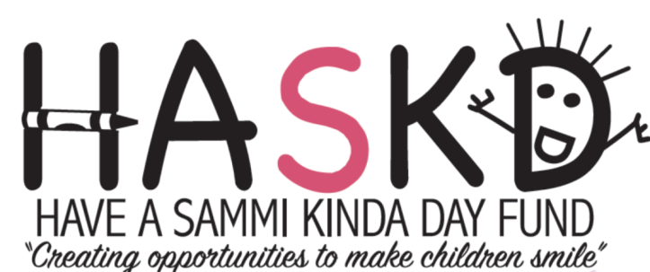

SPONSORSHIP COMMITMENT FORM

PLEASE INDICATE YOUR COMPANY or INDIVIDUAL LEVEL OF SUPPORT:

 Dinner Sponsor – $500
 Hole Sponsor – $100

___________________________________________________________________________

SPONSOR INFORMATION COMPANY/INDIVIDUAL:

Company Name: _____________________________________________________________________

Contact Name______________________________________Title:_____________________________

Address: ________________________________________________________________________

City:_______________________________________ State: __________ Zip: ___________________

Email:__________________________________________________Fax________________________

Phone:_______________________________ Best time to Reach you__________________________

Signature:__________________________________________________ Date: _____________

